https://leetcode.com/problems/count-operations-to-obtain-zero/

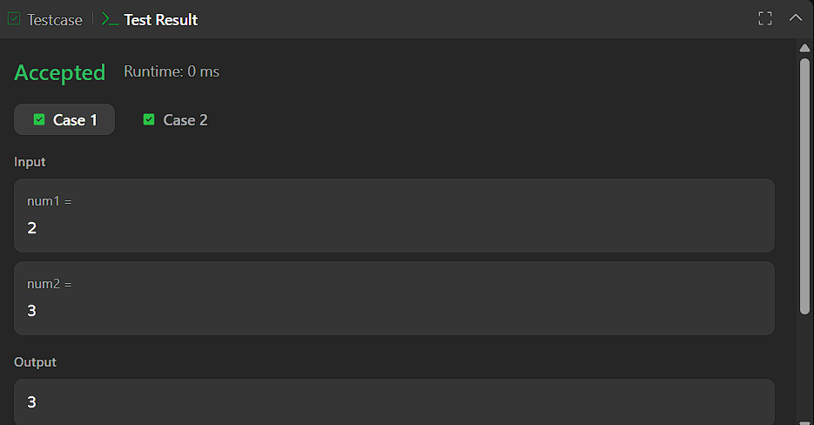


CODE:

int countOperations(int num1, int num2) {
int ops = 0;
while (num1 != 0 && num2 != 0) {
if (num1 >= num2) {
num1 -= num2;
} else {
num2 -= num1;
}
ops++;
}
return ops;
}

